

Europass  Curriculum Vitae |  | 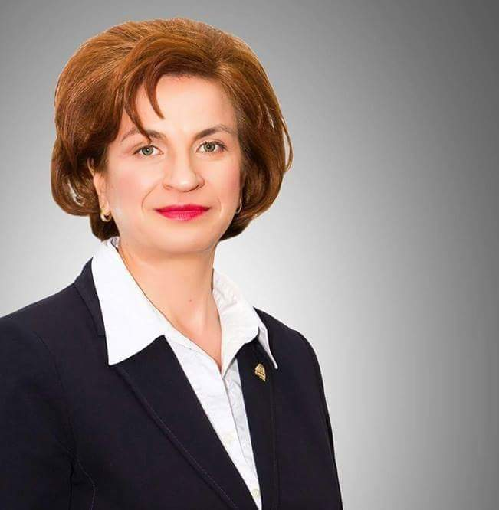
Personal information
First name(s) / Surname(s) |  | Olimpia STATE
Address |  | 6, Romana Square, district 1, Bucharest, postal code: 010374, postal office 22, Romania
Telephone(s) |  | +40213191900/187 |  |  |  |  | Mobile: |  |  |  | +40723695011
Fax |  | +40213191900
E-mail |  | state.olimpia@com.ase.ro
Nationality |  | ROMANIAN
Date of birth |  | 15.07.1969
Gender |  | F
Desired employment / Occupational field |  | PhD, Professor
Work experience
Dates |  | March 2012 onwards
Occupation or position held |  | Vice Dean, Faculty of Business and Tourism (former Commerce)
Main activities and responsibilities |  | Organizing the faculty management research activities
Name and address of employer |  | Bucharest University of Economics Studies, 6, Romana Square, district 1, Bucharest, postal code: 010374, postal office 22, Romania
Type of business or sector |  | Higher Education
Dates |  | March 2008 - March 2012
Occupation or position held |  | Scientific Secretary of The Faculty of Commerce
Main activities and responsibilities |  | Organizing the faculty management activities
Name and address of employer |  | Bucharest University of Economics Studies, 6, Romana Square, district 1, Bucharest, postal code: 010374, postal office 22, Romania
Type of business or sector |  | Higher Education
Dates |  | October 2013 onwards
Occupation or position held |  | Full Professor
Main activities and responsibilities |  | Evaluator (assessor) of doctoral research reports within ASE Doctoral School  Coordinator of dissertations for master programmes and graduation degree  Academic teaching activity in the fields of: Human Resources Management, Operational Technique in Tourism, Organizational Culture, Animators and Animation in Tourism, Business Communication  Member of the Board of review/evaluation of the doctoral thesis
Name and address of employer |  | The Bucharest University of Economic Studies, Bucharest, 6, Piata Romana
Type of business or sector |  | Higher Education
Dates |  | 2007 - 2013
Occupation or position held |  | Associate Professor
Main activities and responsibilities  Name and address of employer  Type of business or sector |  | Evaluator (assessor) of doctoral research reports within ASE Doctoral School  Coordinator of dissertations for master programmes and graduation degree  Academic teaching activity in the fields of: Human Resources Management, Operational Technique in Tourism, Organizational Culture, Animators and Animation in Tourism, Business Communication  The Bucharest University of Economic Studies, Bucharest, 6, Piata Romana  Higher Education
Dates  Occupation or position held  Main activities and responsibilities  Name and address of employer  Type of business or sector |  | 1999-2007  PhD, Lecturer  associate employed in higher education and research  The Bucharest University of Economic Studies, Bucharest, 6, Piata Romana  Higher Education
Dates  Occupation or position held  Main activities and responsibilities  Name and address of employer  Type of business or sector |  | 1993-1999  Assistant prof. PhD student  associate employed in higher education and research  The Bucharest University of Economic Studies, Bucharest, 6, Piata Romana  Higher Education
Education and training
Dates |  | 2008-2010
Title of qualification awarded |  | Graduation Diploma - MBA in English Language Education and Research Communication for Business and Economics
Principal subjects/occupational skills covered |  | Teaching methodology and research skills, communication in English in international academic context, the design of educational and research projects, drafting of scientific articles published in international scientific journals
Name and type of organisation providing education and training |  | The Bucharest University of Economic Studies, Romania
Dates |  | 2009-2010
Title of qualification awarded |  | Certificate for completing in Postgraduate training in Distance Education Management
Principal subjects/occupational skills covered |  | Management of distance education teaching, learning and quality management, design and development of learning materials in technology for distance learning
Name and type of organisation providing education and training |  | The Bucharest University of Economic Studies, Romania
Dates |  | 1996-2001
Title of qualification awarded |  | PhD in Economics (The organizational culture impact of management at microeconomic level)
Principal subjects/occupational skills covered |  | Economics, Human Resource Management, Organizational Culture
Name and type of organisation providing education and training |  | The Bucharest University of Economic Studies, Romania
Dates |  | 1988-1993
Title of qualification awarded |  | Bachelor Diploma in Economic Studies – Faculty of Commerce
Principal subjects/occupational skills covered |  | - Economist/ The company management (in commerce, tourism and services) and specific counseling  - Planning and carrying out effective activities in organization, in economical departments: purchasing, sales, auctions, marketing, logistics, dispatch-transport, advertising, public relations, quality (standard-setting, audit, assessing compliance, quality assurance and control)  - Examining the economic field and its connections and drawing up research reports
Name and type of organisation providing education and training |  | The Bucharest University of Economic Studies, Romania
Personal skills and competences
Mother tongue(s) |  | Romanian
Other language(s)
Self-assessment |  |  | Understanding |  |  |  |  | Speaking |  |  |  |  | Writing
European level (*) |  |  | Listening |  | Reading |  |  | Spoken interaction |  | Spoken production
French |  |  | C2 | Proficient user | C2 | Proficient user |  | C1 | Independ. user | B2 |  | Proficient user | B2 | Proficient user
English |  |  | C1 | Independ. user | C1 | Independ. user |  | B2 | Proficient user | B2 |  | Proficient user | B2 | Proficient user
 |  | (*) Common European Framework of Reference for Languages
Social skills and competences |  | - Team Work: I have coordinated a group of 7 institutions in a research project in which the leading position was occupied by our Academy;  - Mediating skills: In my position of Vice Dean, I have constantly worked at the cooperation between professors, students and administration from our academy;  - Intercultural skills: In 2002-2004 and 2022, I have studied the cultural differences between countries together with an international group formed by representatives from eleven countries. The University of Central Florida occupied the leading position.
Organisational skills and competences |  | During my PhD I organised a seminar series on research methods  Coordinator of students’internship in different types of organisations.
Computer skills and competences |  | Competent with most Microsoft Office Programmes and Internet surfing.
Driving licence |  | Driven license, B category since 2001
Additional information |  | The grade obtained in institutional internal assessment "Very Well" (2023)  Virgil Madgearu Prize awarded by the Romanian Academy in 1999 for "The Human Resources Management" (co-author)  Member of Academic Research Centre in Tourism and Services of the Bucharest University of Economic Studies  Founder of CACTUS Association - Academic Research NGO in Tourism and Services  Author of books and university courses (11), articles and scientific papers published in international and national journals (60), member of research teams  Member of the Faculty Council, since 2008 to present
Selection of books:
- Management of Services (co-author), 2001, Expert Publishing House, ISBN 973-9282-86-5
- Human Resources Management (co-author), 2003, ASE Publishing House, ISBN 973-594-362-X
- The Company Basic Management (co-author), 2004, ASE Publishing House, ISBN 973-594-449-9
- Organizational Culture and Management, 2004, ASE Publishing House, ISBN 973-594-462-6
- Local and International Operational Technique in Tourism (co-author), 2013, C. H. Beck Publishing House, ISBN 978-606-18-0160-2
Selection of papers:
- Ozturk, A. B., Pizam, A., Hacikara, A., An, Q., Chaulagain, S., Balderas-Cejudo, A., ... & State, O. (2023). Hotel customers’ behavioral intentions toward service robots: the role of utilitarian and hedonic values. Journal of Hospitality and Tourism Technology.
- Pizam, A (Pizam, Abraham); Ozturk, AB (Ozturk, Ahmet Bulent); Balderas-Cejudo, A (Balderas-Cejudo, Adela); Buhalis, D (Buhalis, Dimitrios); Fuchs, G (Fuchs, Galia); Hara, T (Hara, Tadayuki); Meira, J (Meira, Jessica); Revilla, MRG (Garcia Revilla, Mercedes Raquel); Sethi, D (Sethi, Deepa); Shen, Y (Shen, Ye); State, O (State, Olimpia); Hacikara, A (Hacikara, Ahmet); Chaulagain, S (Chaulagain, Suja), 2022, FACTORS AFFECTING HOTEL MANAGERS’ INTENTIONS TO ADOPT ROBOTIC TECHNOLOGIES: A GLOBAL STUDY. International Journal of Hospitality Management, vol 102, article nr. 103139, DOI 10.1016/j.ijhm.2022.103139 https://www.sciencedirect.com/science/article/abs/pii/S0278431922000019
- Baicu, C.G., State, O., Gârdan, D.A., Gârdan, I.P. and Țicău, I.R., 2022. Financial and Competitive Implications of the European Green Deal – Perceptions of Retail Managers. Amfiteatru Economic, 24(61), pp. 683-700. https://www.proquest.com/openview/3b5e9b748ecf8eb68bae169b726a6618/1?pq-origsite=gscholar&cbl=1926338
- State, O; Tuclea, CE; (...); Diaconescu, M, ROMANIAN EMPLOYEES' PERCEPTION ON THEIR OWN WORK-LIFE BALANCE - EVIDENCES FROM TOURISM INDUSTRY, BASIQ International Conference on New Trends in Sustainable Business and Consumption, 2019 BASIQ INTERNATIONAL CONFERENCE: NEW TRENDS IN SUSTAINABLE BUSINESS AND CONSUMPTION, pp.204-211
- The Impact of Management and Organizational Culture on Creativity In The Hotel Industry, Amfiteatru economic, Volume: 16, Special Issue: 8 Pages: 1205-1221, Published: NOV 2014, ISSN Print 1582-9146, ISSN Online: 2247–9104.
- The Responsibility of Organisations Towards Customers. Case Study Romanian Travel Agencies Amfiteatru economic, Volume: 16, Issue: 35 Pages: 258-272, Published: FEB 2014, ISSN Print 1582-9146, ISSN Online: 2247–9104.
- Potential Interpretations of the Ecological Behaviour in Tourism, Amfiteatru economic, Volume: 14, Issue: 31, Published: 2012, Pages: 114-128, ISSN 1582-9146.
- The Survey of the Service Quality. Application to a Hotel using the SERVQUAL Model, Amfiteatru economic, Volume: 11, Issue: 26, Published: 2009, Pages: 419-428, ISSN 1582-9146.
- Culture and Internal Competition in Romanian Hospitality Industry: Dimensions and Risks (co-author), in The Business Review, Cambridge, Vol.9, No.2, Summer 2008, USA, pag.125-132, ISSN 1553-5826, indexed in BDI (ProQuest, CABELL’S, ULRICH’S DIRECTORIES);
- Leadership and social responsability, Amfiteatru economic, Volume: 10, Issue: 23, Published: 2008, Pages: 72-79, ISSN 1582-9146.
- The Impact of Organizational Culture on Tourist Satisfaction (co-author), HOTELPLAN 2007, The Third International Congress, The College of Hotel Management Belgrad, 23-24 noiembrie 2007, in Journal for Theory and Practice at Hotel Industry, vol.7, nr. 9-10, year 4 (2007), pp. 541-548, ISBN 86-83777-23-5
- The Relationship between Risk-Taking, Sensation – Seeking, and the Tourist behavior of Young Adults: A Cross – Cultural Study, published in "Journal of Travel Research", "Tourism and Travel Research Association", vol. 42, no. 3, February 2004.
 |  | Traineeship under the DESS “Creation d’Entreprise et Gestion de Projets Innovants” of the University Montesquieu Bordeaux IV - France, "Phare Tempus Individual Mobility Grant", contract no. IMG - 97 - EN - 1037, March-May 1998.
Reviewer (member of the Editorial Review Board) of the EINCO International Conference of the University of Oradea.
Reviewer for the volume Sustainable Approaches and Business Challenges in Times of Crisis, published in 2023 by Springer from the University Babes-Bolyai.

